JOHN HANCOCK - PROJECT COEUS FRONT END
Verification Guide

Revision History
Author | Revision Number | Date
veshu | 1.0 | 5/29/2016
TCSASSEMBLER | 2.0 | 10/21/2016

1. Verifications 2
1.1. Login Page 3
1.2. Home Page 4
1.3. Add Assessment Page 6
1.4. Assessments list Pages 8
1.5. Assessment Detail Page 9
1.6. Assessment Edit Page 13
1.7. Miscellaneous Verification 14
2. Resource Contact List 15

Verifications
- You need to have at least 5 user accounts who can login to the application:
- See Deployment Guide.md at root folder to create the user on AD.
- I have hosted on port 8098, so my URL is http://localhost:8098/
- Insert test data on database by running TestFiles\TestData.sql on your database
- Permissions are as:
- All users can login the application using username and password.
- The owner user can only create assessment.
- Owner can see all assessments created by him/her only
- BUFunctionalApprover can’t see draft and rejected assessments and assessments in which he is not department head/functional owner.
- BURiskManagementApprover can’t see draft, rejected and ‘Awaiting BU Functional Approval’. Also user’s business unit must match to the business unit of assessment to be able to view the assessment.
- DivisionalRiskManagementApprover can only see approved or ‘Awaiting Division Risk Management Approval’ assessments

- Now browse the application and verify

Login Page
- Go to http://localhost:8098/
- Login screen should show as
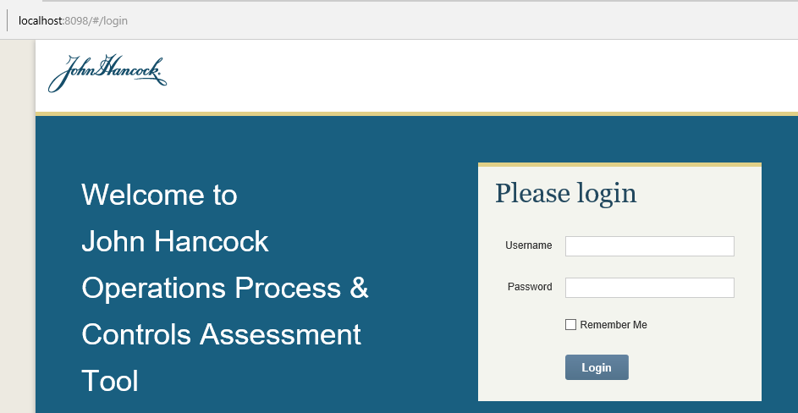
- Click login button without filling value, error should be shown as
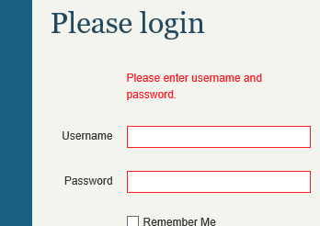
- Enter wrong credentials and verify message

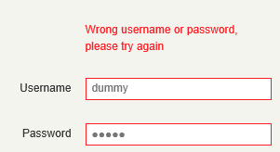

- Login with any approver with correct credentails, you should be redirected to home page

- Try to go to http://localhost:8098/#/addAssessment and see it should not be rendered for other user except user with Owner role
- Verify logout
- Verify “Remember me”
  - Login by selecting the remember me checkbox
  - After successful login close the browser
  - Go to base url (mine is localhost:8098 ) and hit enter
  - You will redirected to home page based on role

- Similarly you can verify login with other credentials if needed.
- To verify token expire, login to the application and then delete all records from [dbo].[Tokens] table
DELETE [Tokens]
And try to perform some action or refresh the page.

Home Page
- Login with Owner user credentials. You should see home page as
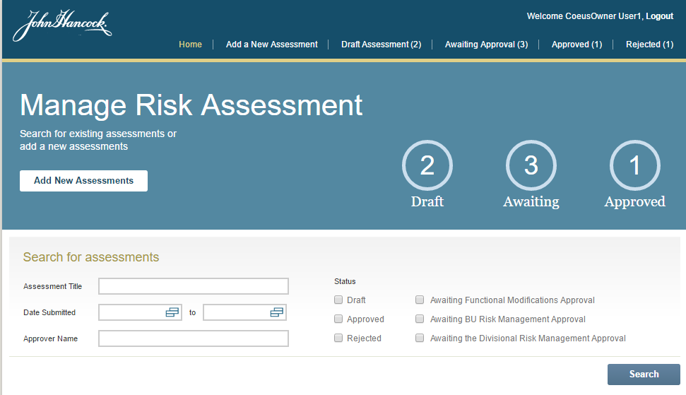
- Click the search button, to get the assessments
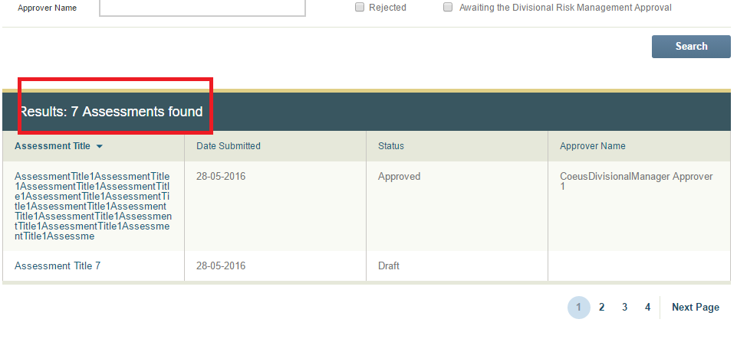
  - Verify the count of assessments
  - Verify the sorting(Sorting from User name is not available)
  - Verify the paging. To see more pages, please update the “DEFAULT_PAGE_SIZE” in Src\App\js\config.js
  - The maximum allowed length in text box is 2000. Otherwise with large text the API can’t handle the request as sent over query string.
  - Click on title of assessment to open detail page
  - When there is only one in search result.
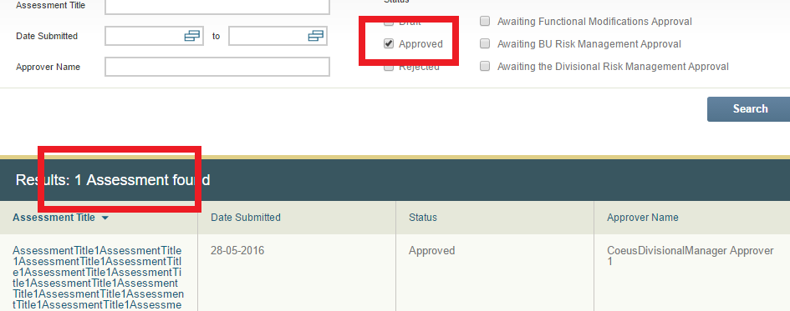
- Similarly, login with approver user. You should see home page as
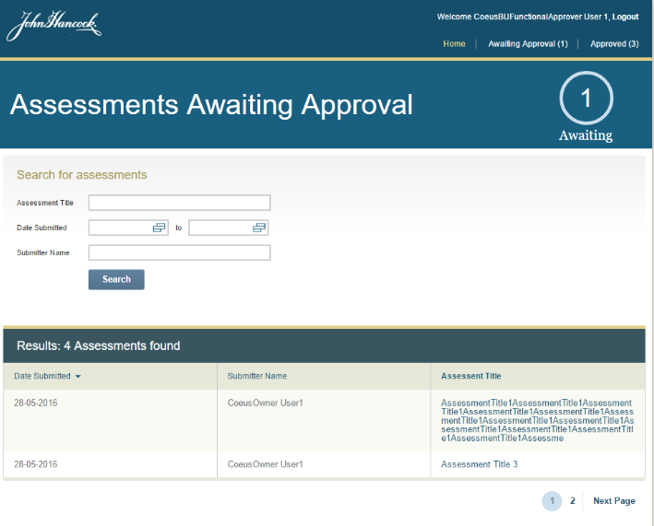
- Verify similar to owner user. Only difference is there is no filter by status.

Add Assessment Page
- Login to the application with owner user
- Click on “Add a New Assessment” link on menu or go to http://localhost:8098/#/addAssessment, following page will shown
Note: The dropdown will take some time to load, depending on your API server performance and network connectivity and there are more lookup items which are called sequentially by browser.
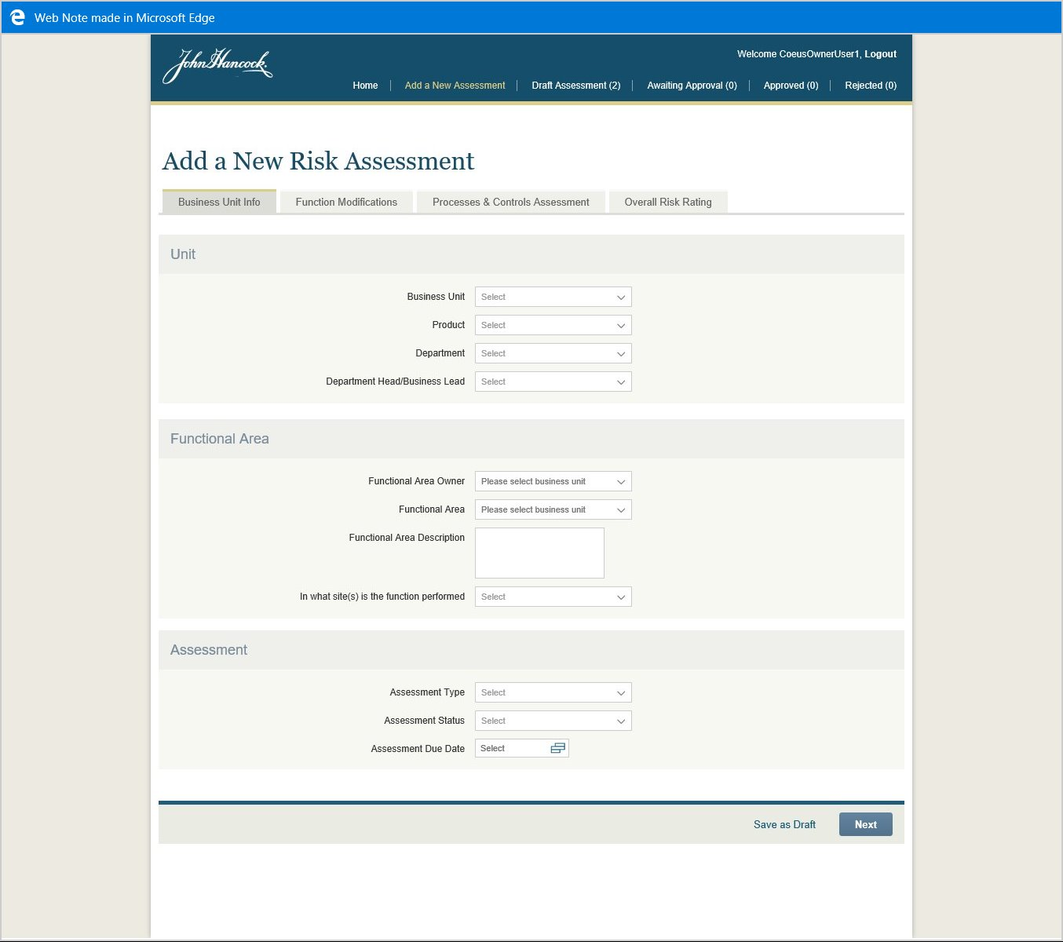

  - Select business unit, then only functional area dropdown will be updated
  - Select functional area
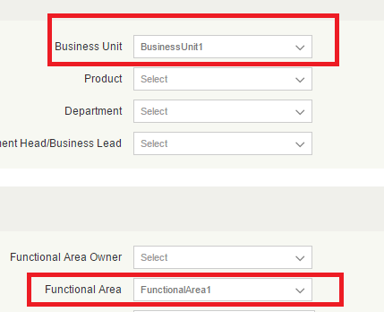
- Now you can save assessment in draft status.
- Click on “Save as draft” button to save in the draft status. You can fill other values as required, which are all optional to save in draft.
- “Function Modification” tab.
  - In this tab, for each control you have to select all three values “Change Type”, “Change Time” and “Change description” otherwise while saving it will be discarded.
- Fill the required values and go to “Overall Risk Rating” tab
  - Verify export, it will download the excel file and prompt to save depending on your browser setting
  - Verify print button, it will use browser’s print functionality
  - Verify Save button to save as draft
  - Verify Submit button to send the assessment for approve.
- Once saved in either draft or with submit after successful operation, you will be redirected to home page.

Assessments list Pages
- Login to the application with owner user(You can verify all link)
- Click on “Draft Assessment” link from menu, the list page will load as
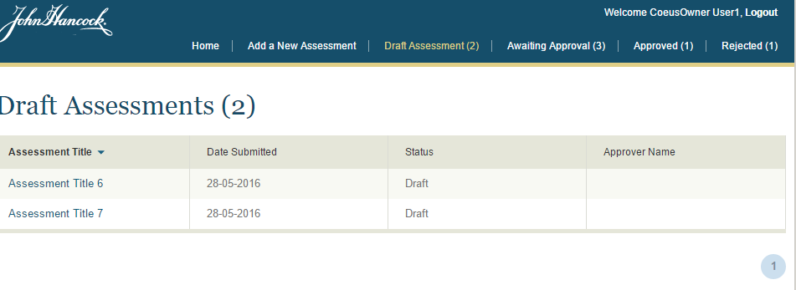
- Similarly, verify other links (Awaiting Approval, Approved, Rejected)
- Now, login with different approver and verify the number of assessments and their status. E.g. with Risk Manager you should see following in awaiting approval
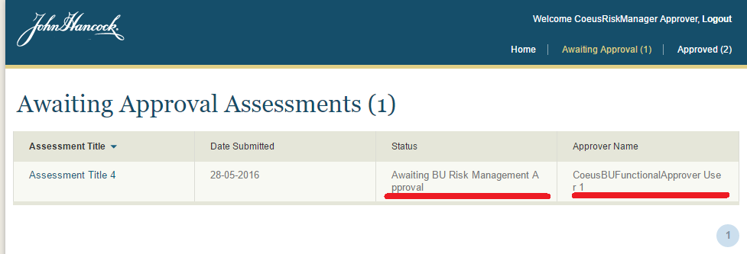

- Click the assessment title to go to detail page.

Assessment Detail Page
- Login with owner user(you will be able to view detail page in all status)
- Draft assessment detail.
  - Open assessment in draft status from home search result or from draft assessment list page. You will see following page
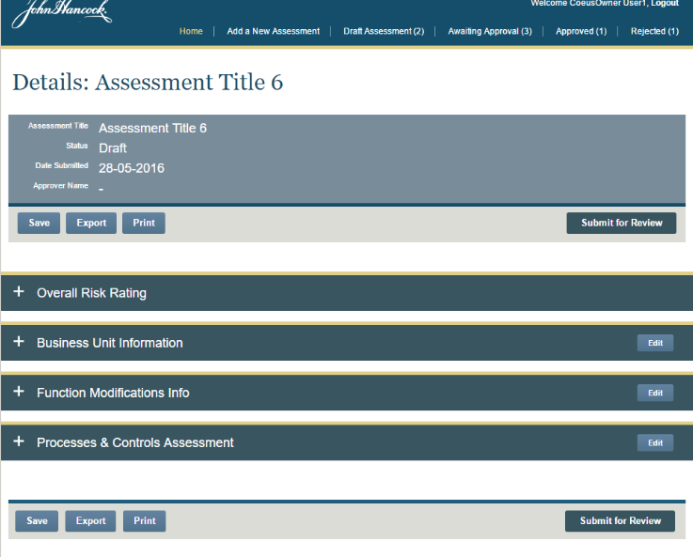
  - Verify save button. (There is only one field here in “Overall Risk Rating” section)
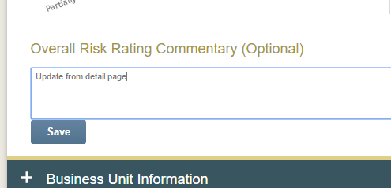
  - Verify Export, Print and submit for review
  - For the detail of this page please refer to verification of 4 tab of add assessment from previous assembly
  - The click on edit button, you will be redirected to edit page. It is very similar to add assessment page with prepopulated detail.

- Awaiting Functional Modifications Approval Assessment detail
  - In this status owner can export and print only.

  - From approver view the page will look like
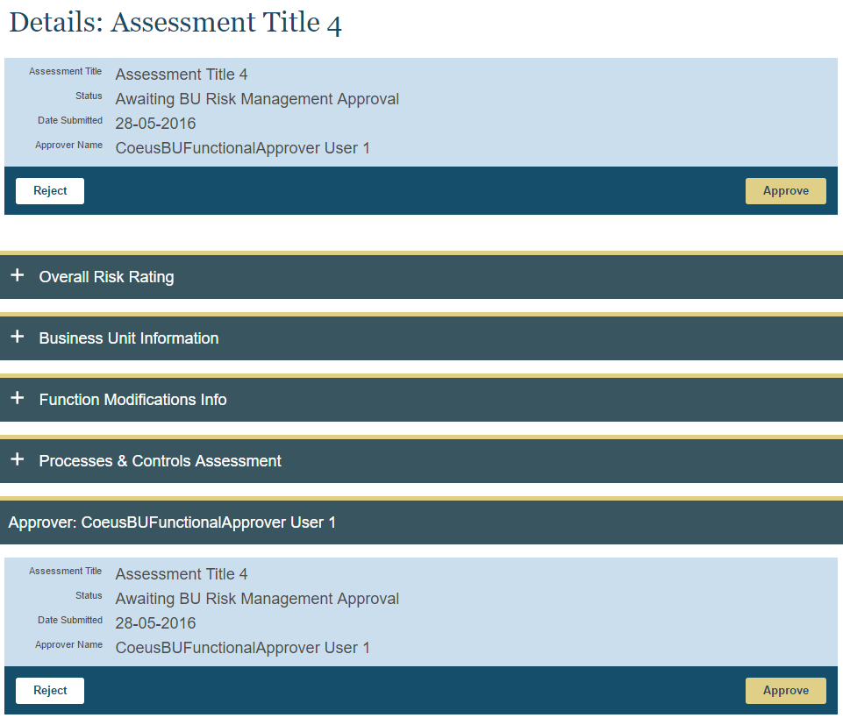

Click on Reject button, it will ask for reason for prompt, which is required.
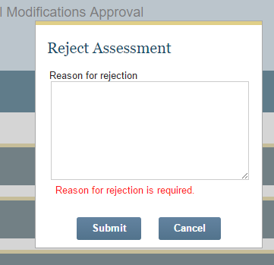

- For other awaiting approval status the detail page will not have the link for edit/save.
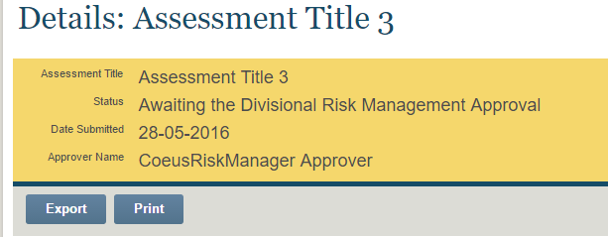

While for approver the view will be same as previous approver.

- Approved Assessment detail Page
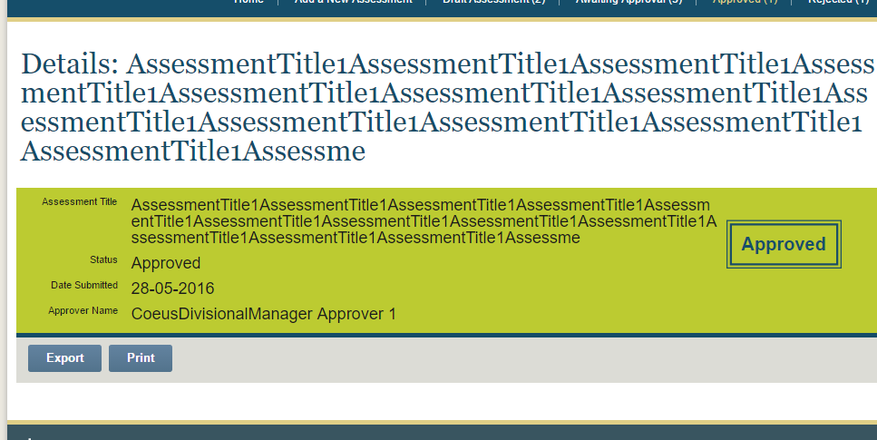
- Rejected assessment detail page
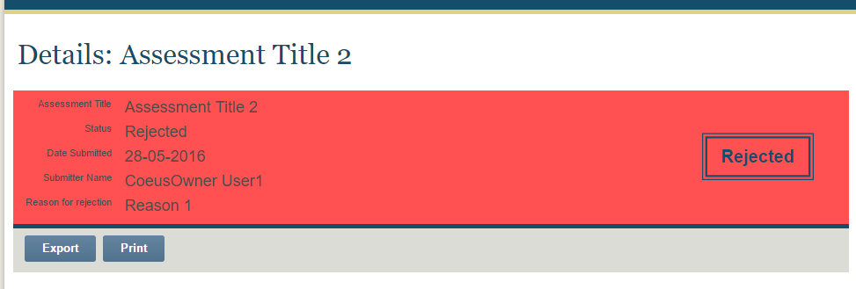

Assessment Edit Page
- Login with owner user
- Open a draft assessment page from search result in home or draft assessment menu and click any edit link from the detail page, you will be redirected to respective tab of edit page.
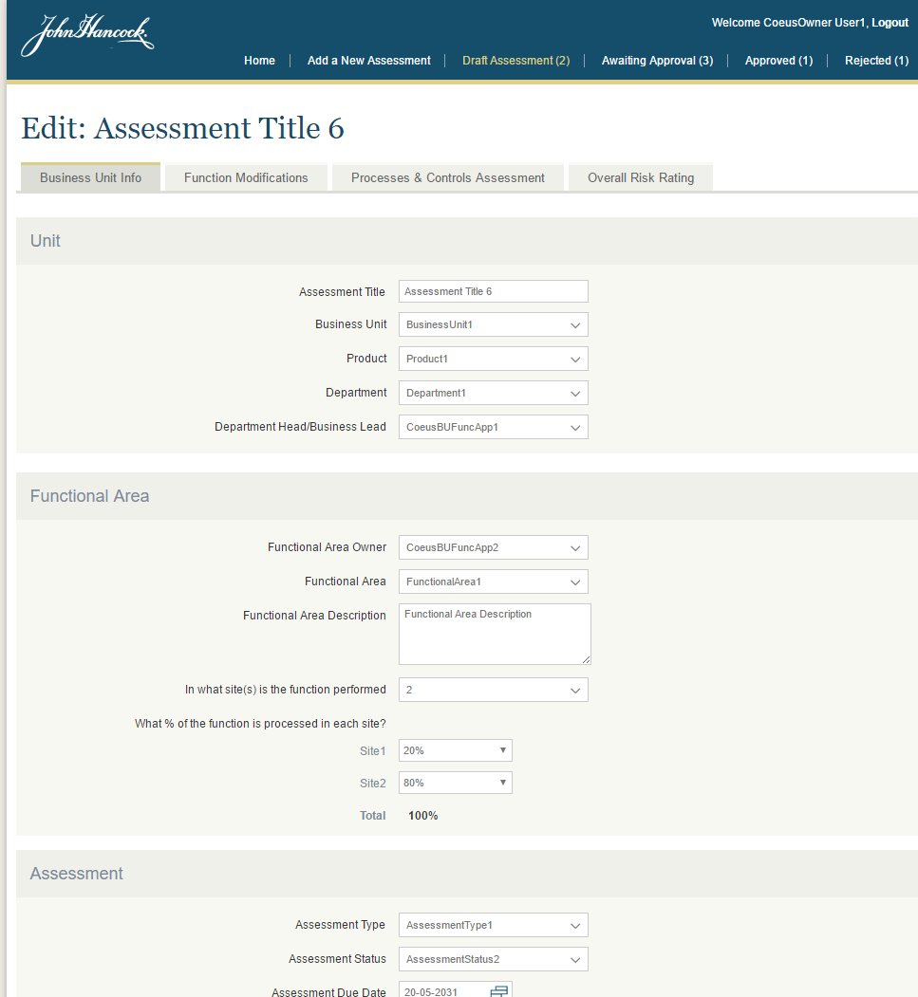
- This page is very similar to add assessment page, so please refer to verification section of deployment guide from assembly 1.

Miscellaneous Verification
- Verify approver can’t see the detail of draft or rejected assessment by entering the different id in URL. E.g. login with approver and enter http://localhost:8098/#/assessmentDetails/6 in URL. It will show the error message as 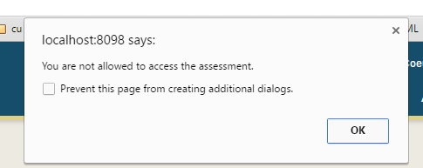
Click ok and you will be redirected to the previous page.
- Verify exported file. The fix includes the test comment reason for not testing in tested column of assessments
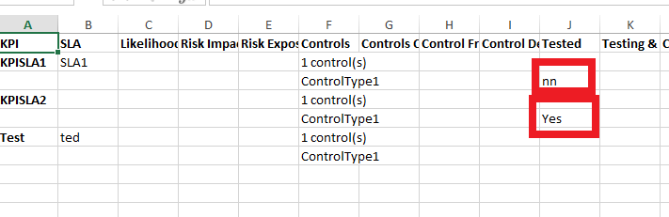
- Verify active menu while refreshing assessment detail page and edit page. The last menu should be highlighted

Resource Contact List

Name | Resource Email

